Derivative of Sigmoid Function
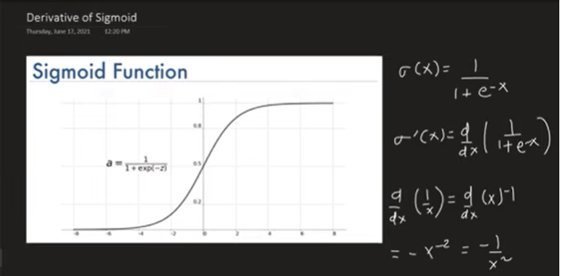
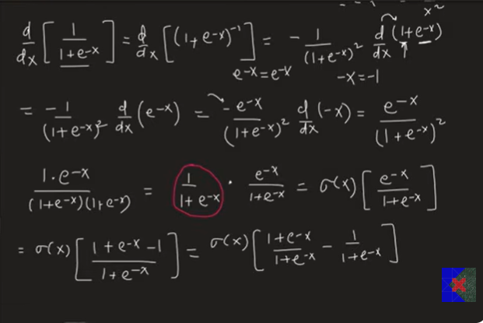
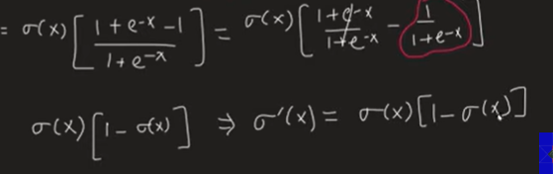
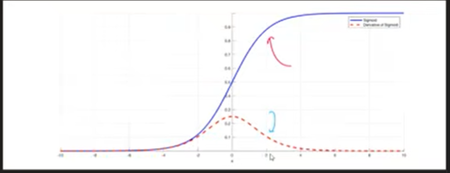

Introduction
The Sigmoid Function is one of the most important activation functions in Machine Learning and Deep Learning.
It is used in:
- Logistic Regression
- Neural Networks
- Perceptrons
- Multi-Layer Perceptrons (MLP)
- Backpropagation
- Gradient Descent
To train these models, we need the derivative of the Sigmoid function.

Sigmoid Function Formula
Sigmoid(x) = 1 / (1 + e^(-x))
Output Range:
0 < Sigmoid(x) < 1
Properties:
- Large positive x → Output approaches 1
- Large negative x → Output approaches 0
- x = 0 → Output = 0.5

Goal
Find
d/dx [Sigmoid(x)]

Step 1
Write the sigmoid function.
Sigmoid(x) = 1 / (1 + e^(-x))
Rewrite it as
Sigmoid(x) = (1 + e^(-x))^(-1)

Step 2
Use the Power Rule.
d/dx [u^(-1)] = -u^(-2) × du/dx
where
u = 1 + e^(-x)

Step 3
Differentiate the inside.
d/dx [1 + e^(-x)]
= -e^(-x)
because
d/dx (1) = 0

d/dx (e^(-x)) = -e^(-x)

Step 4
Substitute into the formula.
d/dx [Sigmoid(x)]

= -(1 + e^(-x))^(-2) × (-e^(-x))
Negative signs cancel.
= e^(-x) / (1 + e^(-x))^2

Step 5
Split the expression.
= [1 / (1 + e^(-x))] × [e^(-x) / (1 + e^(-x))]
Notice
1 / (1 + e^(-x))

= Sigmoid(x)
Also
e^(-x) / (1 + e^(-x))

= 1 - Sigmoid(x)

Final Formula
Sigmoid'(x)

= Sigmoid(x) × (1 - Sigmoid(x))
This is the most important formula.

Example 1
Suppose
Sigmoid(x) = 0.8
Derivative
= 0.8 × (1 - 0.8)

= 0.8 × 0.2

= 0.16

Example 2
Suppose
Sigmoid(x) = 0.5
Derivative
= 0.5 × (1 - 0.5)

= 0.25
This is the maximum value of the Sigmoid derivative.

Important Points
✔ Sigmoid output is always between 0 and 1
✔ Derivative is always positive.
✔ Maximum derivative = 0.25
✔ Derivative becomes almost 0 when the output is close to 0 or 1.
✔ Used in Gradient Descent and Backpropagation.

Formula Sheet (Exam Revision)

Sigmoid Function
Sigmoid(x) = 1 / (1 + e^(-x))

Output Range
0 < Sigmoid(x) < 1

Derivative
Sigmoid'(x)

= Sigmoid(x) × (1 - Sigmoid(x))

Maximum Derivative
Maximum value = 0.25
Occurs when
Sigmoid(x) = 0.5

or

x = 0

Interview Questions

Q1. What is the Sigmoid Function?
Answer
Sigmoid(x) = 1 / (1 + e^(-x))

Q2. What is the derivative of the Sigmoid Function?
Answer
Sigmoid'(x)

= Sigmoid(x) × (1 - Sigmoid(x))

Q3. Where is it used?
- Logistic Regression
- Neural Networks
- Backpropagation
- Gradient Descent
- Binary Classification

Q4. Why is this derivative important?
It is used to calculate gradients during Gradient Descent and Backpropagation.

Q5. What is the maximum value of the derivative?
0.25

From the next notes onward, I'll keep all formulas in plain text (like above) so they're easy to copy into your notebook, Word, or Google Docs without formatting issues.

